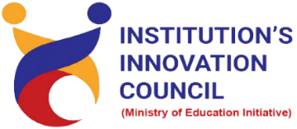
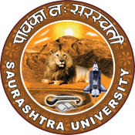
Industrial Visit
U-LIVA Nutrition LLP
29th December 2022
At
Shapar, Rajkot- 360024, Gujarat, India
Contents
Saurashtra University – IIC 2
Event Schedule 2
Event Registration Link 2
Brief about Event 3
Outcome 3
Connect Us: 6

Saurashtra University – IIC
The university is dedicated to instruction, research, and extending knowledge to the public (public service). Ministry of Education (MoE), Govt. of India has established ‘MoE’s Innovation Cell (MIC)’ to systematically foster the culture of Innovation among all Higher Education Institutions (HEIs). The primary mandate of MIC is to encourage, inspire and nurture young students by supporting them to work with new ideas and transform them into prototypes while they are informative years. Saurashtra University is one the Organization that have constituted the IIC to foster the vision of MoE and be a part for the promotion and development of innovation ecosystem.

Event Schedule

Event Registration Link

bit.ly/SUSEC-ULIVA

Brief about Event
Student Start-up and Entrepreneurship Council - Saurashtra University and IIC of Saurashtra University Organized an industrial visit for B.Pharm 3rd semester students on 29th Dec., 2022 at U-LIVA Nutraceuticals LLP., Rajkot for the popularization of Pharmacy at the national level.
“U-Liva Nutrition LLP” founded in the year 2016 are a renowned firm that is engaged in manufacturing and exporting a wide assortment of Herbal and Nutraceutical Capsules, Protein Supplement, Herbal Powder and Organic Quinoa Seed.
Firstly, introduced to Factory co-founder Dr. Rishad Jivani by manager. Then manager of company gave introduction to get basic idea about industry. Industry specialized in tablets, capsule and nutraceuticals products. He also answered various queries of students during his introductory session. As per the visit, student understood Products are developed using scientifically validated ingredients and scientifically supported dosing.
Then we started visit of different areas. First, we visited Wearhouse area which is well maintained and raw materials arranged in well manner. Then we visited QC lab which is well required equipped with different instruments like tablet disintegrator, dissolution, apparatus, fragility tester, hardness tester, etc., Then we had gone through production area, over there we have visited mixers, granulators, tablet punching machines, capsule filling machines, coaters, separate washing area etc., After that we have seen packaging area, the area has well developed with primary packaging and secondary packaging area. Then at last we have visited utility area for AHU (Air Handling Unit), air compression unit, water system, etc.

Outcome

Students have visited the reputed Pharma industry which helps to develop innovative ideas among the students for the research. The visit to U-LIVA Nutraceuticals was really helpful for students in their career enhancement. Students and Faculty of Saurashtra University participated enthusiastically.
It is also learned that the company has an extensive portfolio of herbal supplements and food supplement products. Students got training on raw material/active pharmaceutical ingredient processing and also understand the work flow of solid/liquid oral, injectable and analytical sections.
Students get insight regarding the internal working environment of a company and how a company functions, as well as useful information related to the practical aspects of the education course which cannot be visualized in lectures.
It was very informative and learning experience for students and faculty members.

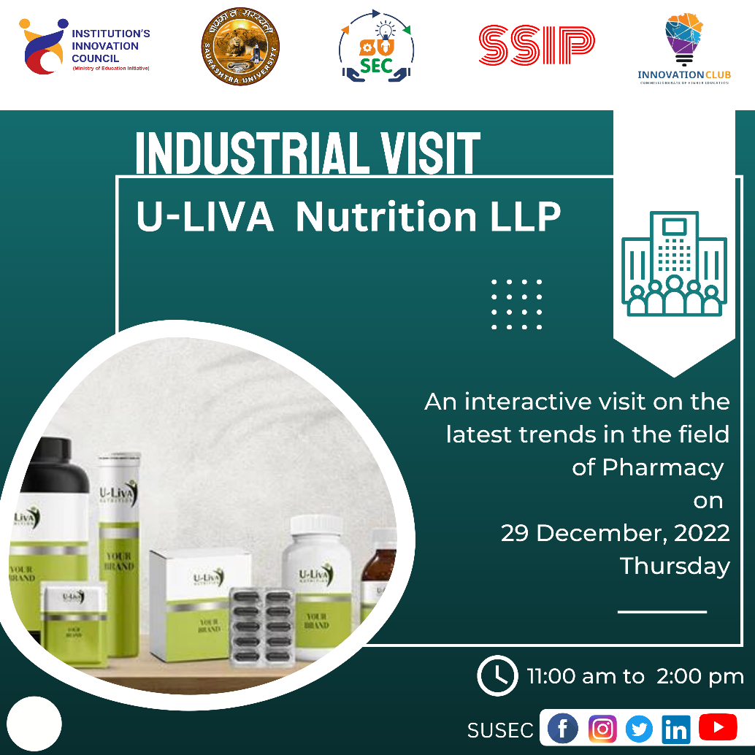

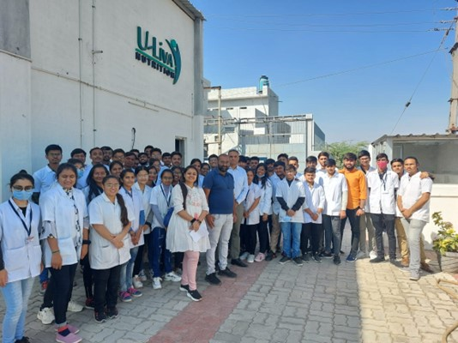

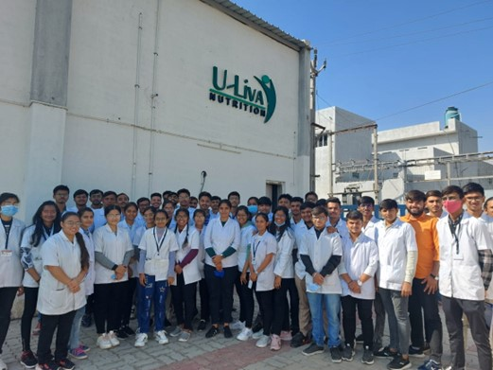
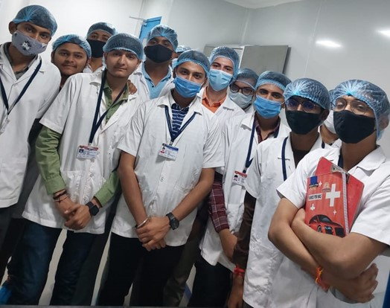

Connect Us:

https://www.linkedin.com/company/susec iic@sauuni.ac.in
https://www.facebook.com/iicsauuni bit.ly/SU-SSIP Location
https://www.instagram.com/susecrajkot https://bit.ly/SUSEC-youtube

